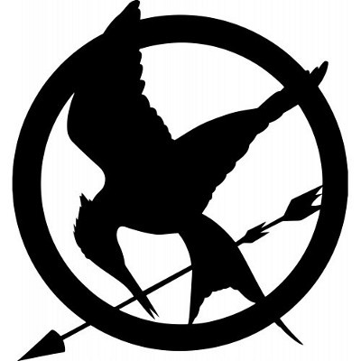
Real or Not ReaL
Hunger Games Trivia

Read through the statements below, decide whether the statement is real (true) or not real (false), and write your answer next to each answer. For one bonus point per not real answer, you can write the actual real answer as well.

- Katniss’ prep team (not including stylists) consisted of Claudius, Venia, and Octavia. (Not real - Flavius)
- Katniss’ name was in the first reaping bowl 20 times. (real)
- Sponsor gifts were sent into the arena with black silk parachutes. (not real - silver)
- Katniss received burn cream as a sponsor gift right after kissing Peeta. (not real - broth)
- Katniss’ favorite color is green. (real)
- Haymitch is 41 years old. (real)
- Katniss’ nickname for her sister Prim is little goose. (not real - little duck)
- On the day after Peeta gave Katniss burnt bread for the first time, Katniss saw a daisy on the way to school, which gave her hope. (not real - dandelion)
- Beetee makes Katniss a special bow that is touch activated. (Not real - voice activated)
- Madge gives Katniss the mockingjay pin she wears throughout the games. (real)
- The very first piece of advice Haymitch gives the tributes from District 12 is to stay alive. (real)
- Peeta’s stylist’s name is Venia. (not real - Portia)
- In her private training session, Katniss scores an 11 from the gamemakers. (real)
- Glimmer kills Rue in the first Hunger Games. (not real - Marvel)
- In the Quarter Quell reaping, Peeta and Katniss’ names are chosen again from the reaping bowl. (not real - Haymitch and Katniss)
- Finnick Odair is one of the tributes from District 8. (not real - District 4)
- Avoxes have their eyes cut out, leaving them blind. (not real - tongues, mute)
- When Katniss visits District 12 at the beginning of Mockingjay, she finds Prim’s cat Buttercup and brings it back with her. (real).
- In the first Mockingjay promo movie that actually airs, Katniss says “we fight, we dare, we end our hunger for justice.” (not real - And if we burn, you burn with us.”)
- At the end of Mockingjay, Katniss kills the President of Panem. (real - Presdient Coin is the new president of Panem)

